WRITTEN WORK CONTRACTUAL AGREEMENT

Dear NAME :

This letter will serve as a contract between you and the Office of Northland College Student Publications (NCSP). Your signature below confirms your submission of (an) original written work(s) for the limited-run printed and indefinitely digitally available Mosaic literary and visual arts magazine and/or Drifts/Slush, the NC newspaper. This contract applies when NCSP publishes any and all of your written works. Please review, sign, and return.

Your signature guarantees (1) that the writing you submit is your own, free of plagiarism; (2) that the facts contained in the written work are accurate to the best of your knowledge; (3) that the work has not been previously published, either in whole or in part; and (4) that you have used reasonable care to ensure that the work does not violate the rights of privacy or libel or infringe any other rights of any person.

You agree to grant NCSP the first North American serial rights to the written work, exclusive to NCSP until you sell any subsequent rights, at which point you agree to request that all subsequent publishers credit NCSP as the first publisher of the written work. NCSP retains the right to not publish any at all written work(s). NCSP does not provide any reimbursement associated with or in connection to your written work unless otherwise agreed. NCSP may use captures of NCSP-generated publications on social media to advertise, which may include references to and segments of your written work.

You and NCSP understand and agree to the following general provisions of this contract:
Assignment – NCSP is bound by this agreement and may not assign it to other individuals or businesses without your express written consent. Severability – If any of the provisions of this agreement are found to be invalid, illegal, or unenforceable in any respect, the validity, legality, and enforceability of the remaining provisions will not be affected. Entirety – No terms or conditions outlined in this agreement may be modified by either party without the express consent of both parties, in writing. Notice – Any notices from yourself pertaining to this agreement or your written work(s) should be sent via e-mail to StudentPublications@Northland.EDU. NCSP will send any such notices to your associated e-mail address.

I am delighted that you have agreed to provide an original written work for the NCSP’s Mosaic. If you have any questions, please e-mail or call using the contact information below.

With warm regards,
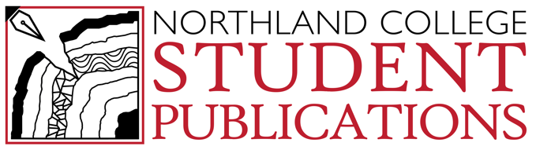
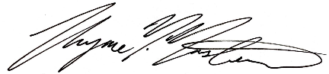
Thyme M. Masters
Director of NCSP, P.R. Manager
StudentPublications@Northland.EDU
(715) 682-1287

Please sign below to indicate your agreement to the terms above and return one copy as a scanned document to StudentPublications@Northland.EDU.

NAME
Signature: Date:
E-Mail Address:
Northland College Student Publications (NCSP)
Signature: Date:
Title:

