PAID STAFF AGREEMENT

Dear NAME :

This letter will serve as a contract between you and the Office of Northland College Student Publications (NCSP). Your signature below confirms your appointment as a paid staff member of NCSP, either as a hired contributing writer to Drifts/Slush, as an Editor of Drifts/Slush, Mosaic, or Wedge, or any combination thereof. Please review, sign, and return.

Duties of positions are varied as described in the staff handbook that you have received. By accepting appointment to this position in NCSP you agree to provide written and visual content on a reliable basis as stipulated in said handbook and other communique by assigned deadlines. As a paid staff member of NCSP you acknowledge that any content submitted to NCSP may be published in any NCSP publication forevermore, all of which are available as a limited-run print publication and indefinitely online at the NCSP website. All content submitted by paid staff members is deemed rightly compensated for in a financial sense and such content is innately absorbed as the intellectual property of NCSP, and as such, may be used at NCSP’s discretion indefinitely.

Additionally, as a member of NCSP who may have uninhibited access to the NCSP office Mead 233/235, you hereby agree not to disclose any confidential information pertaining to NCSP, such as log-in and server information, beyond the confines of other NCSP members designated by signature upon this agreement. In the same vein, some office property is available on loan to you when checked out following standard procedure communicated with the NCSP Director. Additionally, many possessions in the NCSP office are those of individual staff members and must not be tampered with or removed from the NCSP office without the express consent of its individual owner.

Your signature guarantees (1) that the written and visual content you submit is your own, free of plagiarism; (2) that the facts contained in the written content are accurate to the best of your knowledge; (3) that the written and visual content has not been previously published, either in whole or in part; and (4) that you have used reasonable care to ensure that the written and visual content does not violate the rights of privacy or libel or infringe any other rights of any person.

You and NCSP understand and agree to the following general provisions of this contract:
Assignment – NCSP is bound by this agreement and may not assign it to other individuals or businesses without your express written consent. Severability – If any of the provisions of this agreement are found to be invalid, illegal, or unenforceable in any respect, the validity, legality, and enforceability of the remaining provisions will not be affected. Entirety – No terms or conditions outlined in this agreement may be modified by either party without the express consent of both parties, in writing. Notice – Any notices from yourself pertaining to this agreement or your written and visual content should be sent via e-mail to StudentPublications@Northland.EDU. NCSP will send any such notices to your associated e-mail address.

I am delighted to welcome you officially to the NCSP team. If you have any questions, please e-mail or call using the contact information below.

With warm regards,
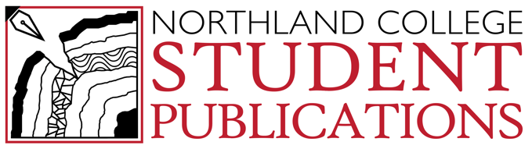
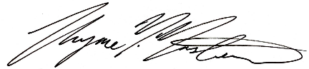
Thyme M. Masters
Director of NCSP, P.R. Manager
StudentPublications@Northland.EDU
(715) 682-1287

Please sign below to indicate your agreement to the terms above and return one copy as a scanned document to StudentPublications@Northland.EDU.

NAME
Signature: Date:
E-Mail Address:
Title:
Northland College Student Publications (NCSP)
Signature: Date:
Title:

